
Business Question and Visualization Report

Date | 20/10/2026
Team ID | Shried Mandloi
Project Name | Electric Vehicle Market Performance & Insights
Maximum Marks | 5 Marks

Visualization development refers to the process of creating graphical representations of data to facilitate understanding, analysis, and decision-making. The goal is to transform complex datasets into visual formats that are easy to interpret, enabling users to gain insights and make informed decisions. Visualization development involves selecting appropriate visual elements, designing layouts, and using interactive features to enhance the user experience. This process is commonly associated with data visualization tools and platforms, and it plays a crucial role in business intelligence, analytics, and reporting
Business Questions and Visualisation
The process involves defining specific business questions to guide the creation of meaningful and actionable visualizations in Tableau. Well-framed questions help in identifying key metrics, selecting relevant data, and building visualisation that provide insights.
1. What are the key performance indicators of the electric vehicle market?
- Visualization: KPI cards displaying Total Sales, Average price, and Average Range.
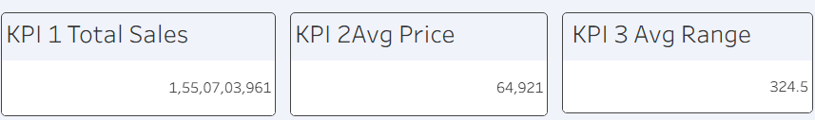
2. How have electric vehicle sales changed across different model years?
- Visualization: Line chart showing the Sales Trend by Model Year.
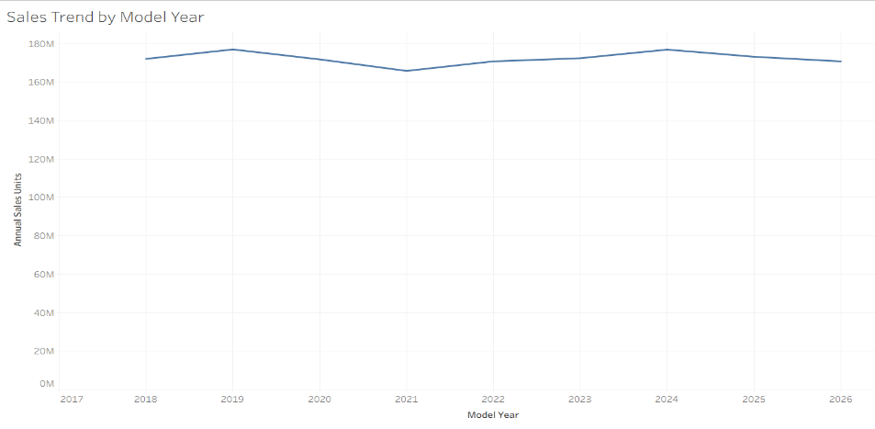

.

3. How are annual EV sales distributed across different drivetrain types?
- Visualization: Pie chart showing Annual Sales Distribution by Drivetrain.
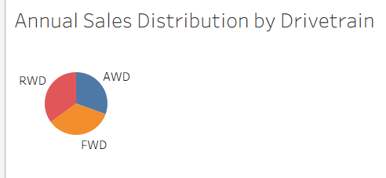

4. How does the average price vary across different EV categories?
- Visualization: Vertical bar chart comparing Average Price by EV Category.
- 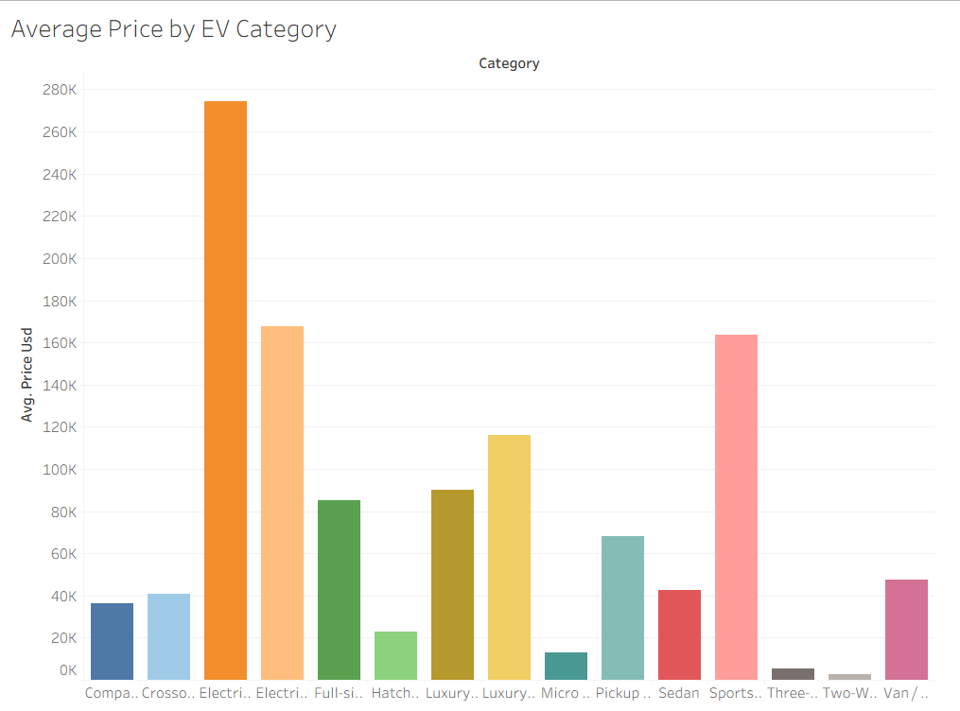

5. Which market regions generate the highest total EV sales?
- Visualization: Horizontal bar chart showing Total Sales by Market Region.
- 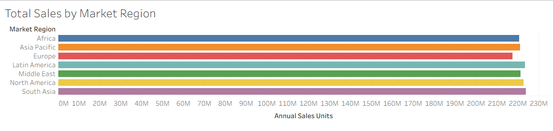.

6. How are electric vehicle sales distributed across different countries globally?
- Visualization: Global map visualization showing Global EV Sales by Country.
- 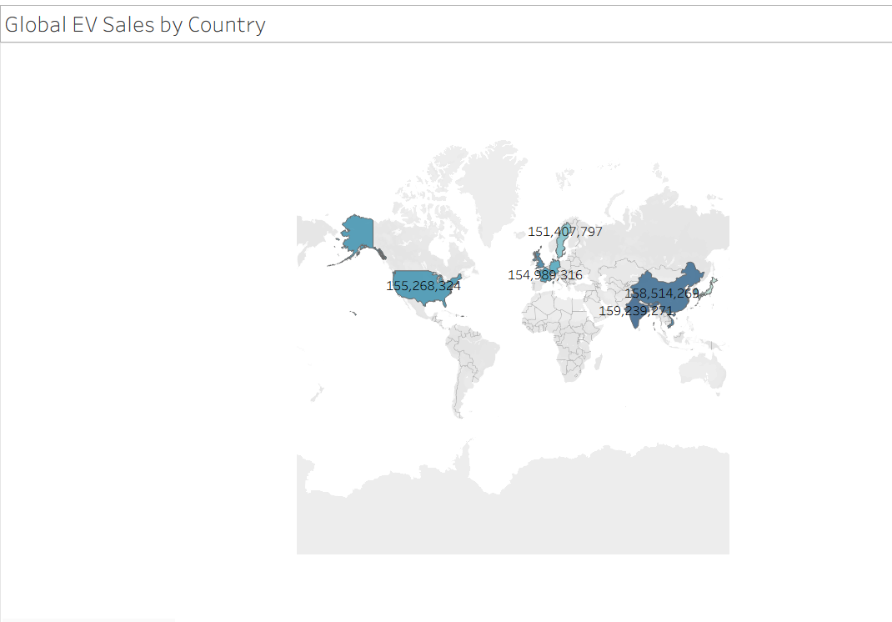

7. How does customer satisfaction vary across different EV categories?
- Visualization: Heat map showing Customer Rating by EV Category.
- 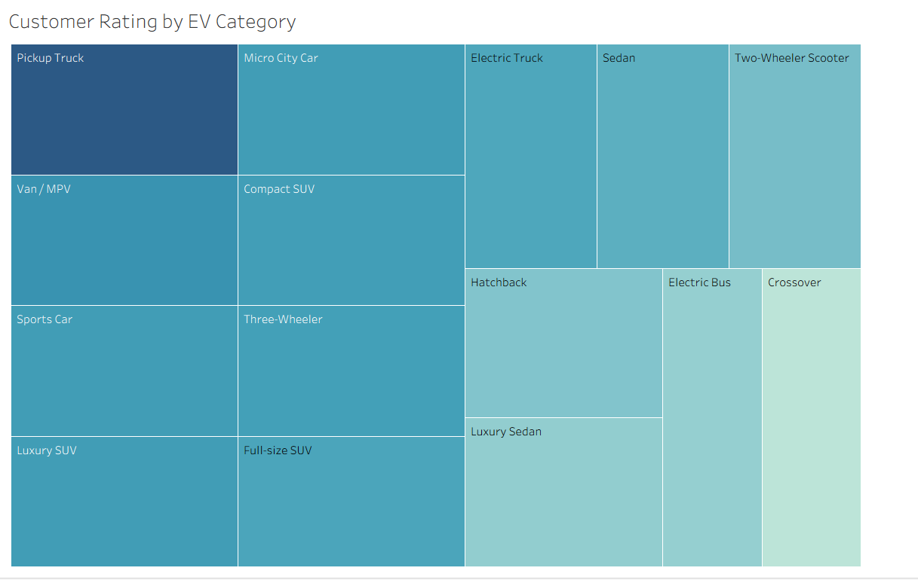

8. How do key EV performance characteristics compare across the market?
- Visualization: KPI-based comparative analysis of Total Sales, Average Price and Average Range to understand the overall performance characteristics of EVs.
- 